**Activity Diagram**

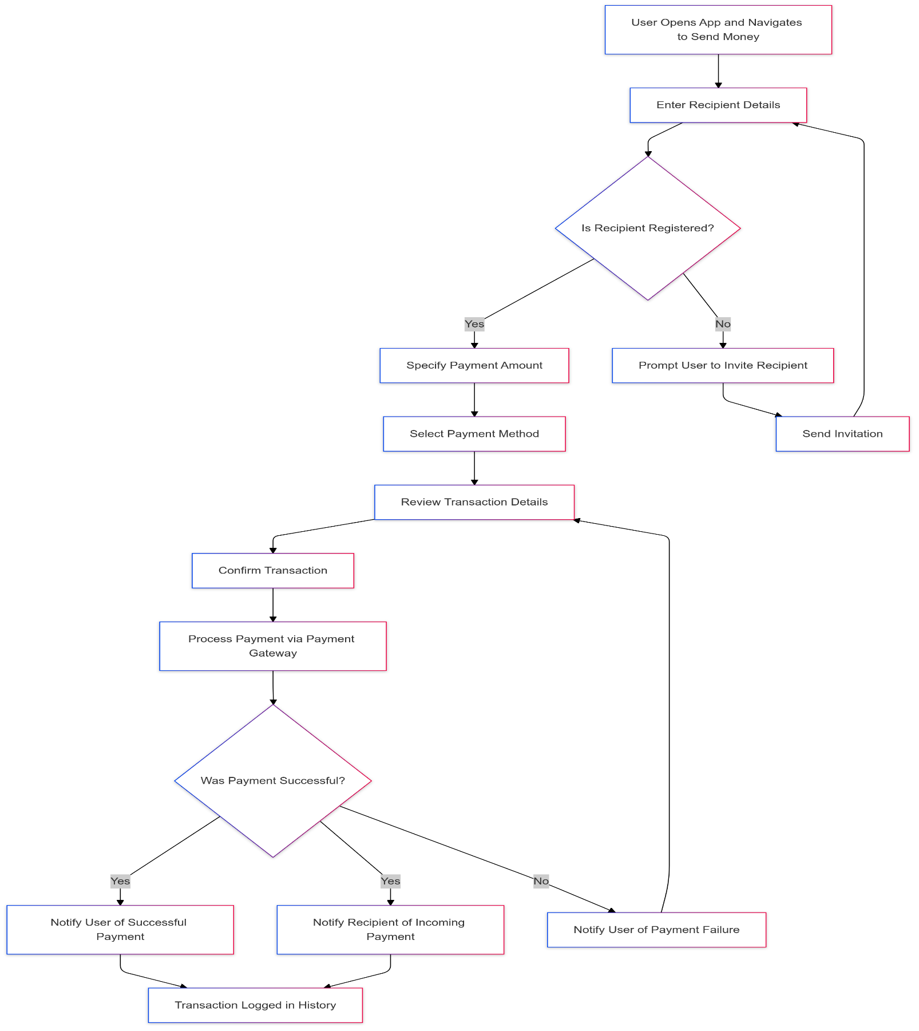

Fig: Activity Diagram